SAT Test Information

Looking for an upcoming SAT or SAT Subject Tests™?
Register at: http://sat.collegeboard.org/register
SAT Date | Register-By Date* | Late Registration* |  | Changes By*
 |  | Mail | Phone/  Online
October 3, 2015 | September 3, 2015 | Sept. 18, 2015 | Sept. 22, 2015 | Sept. 22, 2015
November 7, 2015 | October 9, 2015 | Oct. 23, 2015 | Oct. 27, 2015 | Oct. 27, 2015
December 5, 2015 | November 5, 2015 | Nov. 20, 2015 | Nov. 23, 2015 | Nov. 23, 2015
January 25, 2016 | December 28, 2015 | Jan. 8, 2016 | Jan. 12, 2105 | Jan. 12, 2016
March 5, 2016 | February 5, 2016 | Feb. 19, 2016 | Feb 23, 2016 | Feb. 23, 2016
May 7, 2016 | April 8, 2016 | April 22, 2016 | April 26, 2016 | April 26, 2016
June 4, 2016 | May 5, 2016 | May 20, 2016 | May 25, 2016 | May 25, 2016
Additional fees apply if you register late or make changes to your test type, center or date after registering.

Fees
SAT Fees
Regular registration with Essay | Registration without Essay  (March-June 2016) | Late registration Fee
$54.50 | $43.00 | +$28.00

SAT Subject Test Fees
Base fee | Language with Listening Tests | All other Subject Tests
$26  (per test date) | + $26  (per test) | + $18  (per test)

Create Your Own Study Plan: http://sat.collegeboard.org/practice/sat-study-plan

ACT TEST Information
The ACT® test assesses high school students' general educational development and their ability to complete college-level work.
- The multiple-choice tests cover four skill areas: English, mathematics, reading, and science.
- The Writing Test, which is optional, measures skill in planning and writing a short essay.
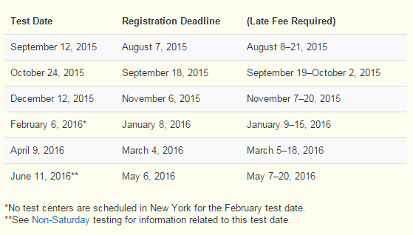
Register at: http://www.actstudent.org/regist/

2016– 2016 ACT Fees and Services
All fees are nonrefundable unless otherwise noted. Additional fees may apply to individual situations.

Basic registration fee
ACT (No Writing) | $39.50
Includes reports for you, your high school (if you authorize reporting), and up to four college choices
ACT Plus Writing | $56.50
Includes reports for you, your high school (if you authorize reporting), and up to four college choices. The $15.00 Writing Test fee is refundable, on written request if you are absent on test day or switch to the ACT (No Writing) before testing begins.

Additional registration fees and services
Add to the basic fee for your test option (except for the Test Center Change)
Late registration fee (U.S. or Canada only) | add $25.00
Test date change | add $24.00
Test center change | add $24.00
Viewing scores online | FREE

